|  |  |
| --- | --- |
| **Sony Alpha A9 Mark II Camera**  Máy ảnh Sony Alpha A9 Mark II | Chính hãng  Sony Alpha A9 mark 2  Chính hãng.1 Sony Alpha A9 mark 2  Chính hãng.2 Sony Alpha A9 mark 2  Chính hãng.5 Sony Alpha A9 mark 2  Chính hãng.4 | **Featured information:**   * Sensor: Full-Frame * ISO range: 100 - 51200 (expandable 50 - 204800) * Resolution: 24.2MP * Wireless connection: WiFi, bluetooth   Price : 5000$  **Specifications:**   * **Sensor Format:** Full-Frame (1x Crop Factor) * **Resolution:** 28.3 megapixels * **Size photo:** 6000 x 4000 * **Image Proportions:** 1:1, 3:2, 4:3, 16:9 * **Sensor Type:** CMOS * **Image Format:** 35.6 x 23.8 mm * **Anti-Vibration:** Sensor-Shift, 5-Axis * **Lens Mount:** Sony E |

**Description:**

#### **Fast Hybrid AF focusing technology**

The camera features a 24.2MP Exmor RS BSI CMOS sensor coupled with the BIONZ X image processor for fast and impressive performance. With this sensor, the camera can shoot continuously at 20 frames per second with the electronic shutter or continuously shoot at 10 frames per second with the mechanical shutter. The sensor's back-illuminated design also provides high light sensitivity with ISO ranging from 100 - 51200 and expandable from 50 - 204800. This reduces noise creating high quality images in a variety of lighting conditions together

#### **Design of Sony A9 Mark II (ILCE-9M2)**

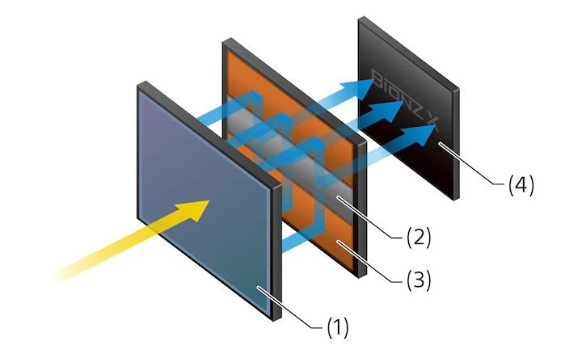

The Fast Hybrid AF system combines 693 phase-detection focus points with 425 contrast detection areas to help quickly and accurately focus on subjects in many lighting conditions. The camera integrates high-density focusing technology combined with focusing algorithms that allow detailed tracking of subject movements.

